Supplementary Material
Supplementary Table 1. PubMed Search Algorithm
metafor: A Meta-Analysis Package for R. (Accessed 1 April 2022). https://www.rdocumentation.org/packages/metafor/versions/3.0-2/topics/metafor-package
Strategy Number | Search Terms | Search Hits  (June 11, 2018) | Search Hits  (Feb 4, 2019)
1 | "multiple sclerosis"[Title/Abstract] OR "relapsing-remitting multiple sclerosis"[Title/Abstract] OR "relapsing remitting multiple sclerosis"[Title/Abstract] OR "remitting relapsing multiple sclerosis"[Title/Abstract] OR "remitting-relapsing multiple sclerosis"[Title/Abstract] OR "rrms"[Title/Abstract] | 66,629 | 69,413
2 | "dimethyl fumarate"[Title/Abstract] OR fingolimod[Title/Abstract] OR "glatiramer acetate"[Title/Abstract] OR interferon[Title/Abstract] OR teriflunomide[Title/Abstract] OR “mitoxantrone”[Title/Abstract] OR "bg 12"[Title/Abstract] OR bg-12[Title/Abstract] OR alemtuzumab[Title/Abstract] OR ocrelizumab[Title/Abstract] OR daclizumab[Title/Abstract] OR natalizumab[Title/Abstract] OR peginterferon[Title/Abstract] OR rituximab[Title/Abstract] OR tecfidera[Title/Abstract] OR gilenya[Title/Abstract] OR glatopa[Title/Abstract] OR copaxone[Title/Abstract] OR avonex[Title/Abstract] OR rebif[Title/Abstract] OR betaseron[Title/Abstract] OR extavia[Title/Abstract] OR aubagio[Title/Abstract] OR novantrone[Title/Abstract] OR lemtrada[Title/Abstract] OR ocrevus[Title/Abstract] OR tysabri[Title/Abstract] OR plegridy[Title/Abstract] OR zinbryta[Title/Abstract] OR rituxan[Title/Abstract] | 166,609 | 171,633
3 | effectiveness[Title/Abstract] OR relapse[Title/Abstract] OR disability[Title/Abstract] OR worsening[Title/Abstract] OR progression[Title/Abstract] OR accumulation[Title/Abstract] OR "annualized relapse rate"[Title/Abstract] OR "annualised relapse rate" [Title/Abstract] | 1,369,711 | 1,438,848
4 | "Cohort Studies"[Mesh] OR "Cross-Sectional Studies"[Mesh] OR "Electronic Health Records"[Mesh] OR "Registries"[Mesh] OR "Observational Study"[Publication Type] OR "cross-sectional"[Title/Abstract] OR cohort[Title/Abstract] OR "electronic medical record"[Title/Abstract] OR "electronic health record"[Title/Abstract] OR regist*[Title/Abstract] OR "observational"[Title/Abstract] OR "longitudinal"[Title/Abstract] OR "prospective"[Title/Abstract] OR "retrospective"[Title/Abstract] OR "real-world"[Title/Abstract] OR "real world"[Title/Abstract] OR "cross sectional"[Title/Abstract] OR database [Title/Abstract] OR "nonexperimental"[Title/Abstract] OR "non-experimental"[Title/Abstract] OR "nonrandomized"[Title/Abstract] OR "nonrandomised"[Title/Abstract] OR "non-randomised"[Title/Abstract] OR "non-randomized"[Title/Abstract] OR "propensity score"[Title/Abstract] OR "propensity scores"[Title/Abstract] OR "propensity scoring"[Title/Abstract] OR confound*[Title/Abstract] OR "selection bias"[Title/Abstract] | 3,069,517 | 3,234,249
5 | #1 AND #2 AND #3 AND #4 NOT "Animals"[MeSH:noexp] Filters: English; Abstract; Publication date from 2010/01/01 to 2018/12/31 (2018/05/01 to 2019/02/06 for SLR Update) | 769 | 122

Supplementary Table 2. Embase Search Algorithm
Strategy Number | Search Terms | Search Hits  (June 11, 2018) | Search Hits  (Feb 4, 2019)
1 | 'multiple sclerosis':ti,ab OR 'relapsing-remitting multiple sclerosis':ti,ab OR 'relapsing remitting multiple sclerosis':ti,ab OR 'remitting relapsing multiple sclerosis':ti,ab OR 'remitting-relapsing multiple sclerosis':ti,ab OR 'rrms':ti,ab | 100,638 | 104,771
2 | 'dimethyl fumarate':ti,ab OR fingolimod:ti,ab OR 'glatiramer acetate':ti,ab OR 'interferon':ti,ab OR 'teriflunomide':ti,ab OR 'mitoxantrone':ti,ab OR 'bg 12':ti,ab OR 'bg-12':ti,ab OR 'alemtuzumab':ti,ab OR 'ocrelizumab':ti,ab OR 'daclizumab':ti,ab OR 'natalizumab':ti,ab OR 'peginterferon':ti,ab OR rituximab:ti,ab OR tecfidera:ti,ab OR gilenya:ti,ab OR glatopa:ti,ab OR copaxone:ti,ab OR avonex:ti,ab OR rebif:ti,ab OR betaseron:ti,ab OR extavia:ti,ab OR aubagio:ti,ab OR novantrone:ti,ab OR lemtrada:ti,ab OR ocrevus:ti,ab OR tysabri:ti,ab OR plegridy:ti,ab OR zinbryta:ti,ab OR rituxan:ti,ab | 230,714 | 238,944
3 | 'cohort analysis'/de OR 'cross-sectional study'/de OR 'electronic medical record'/de OR 'electronic health record'/de OR 'register'/de OR 'data base'/de OR 'observational study'/de OR 'cross-sectional':ti,ab OR cohort:ti,ab OR 'electronic medical record':ti,ab OR 'electronic health record':ti,ab OR regist*:ti,ab OR 'observational':ti,ab OR 'longitudinal':ti,ab OR 'prospective':ti,ab OR 'retrospective':ti,ab OR 'real-world':ti,ab OR 'real world':ti,ab OR 'cross sectional':ti,ab OR 'database':ti,ab OR 'nonexperimental':ti,ab OR 'non-experimental':ti,ab OR 'nonrandomized':ti,ab OR 'nonrandomised':ti,ab OR 'non-randomised':ti,ab OR 'non-randomized':ti,ab OR 'propensity score':ti,ab OR 'propensity scores':ti,ab OR 'propensity scoring':ti,ab OR confound*:ti,ab OR 'selection bias':ti,ab | 3,208,753 | 3,446,402
4 | 'effectiveness':ti,ab OR 'relapse':ti,ab OR 'disability':ti,ab OR 'worsening':ti,ab OR 'progression':ti,ab OR accumulation:ti,ab OR 'annualized relapse rate':ti,ab OR 'annualised relapse rate':ti,ab | 1,870,820 | 1,982,225
5 | #1 AND #2 AND #3 AND #4 AND [english]/lim AND [abstracts]/lim AND [2010-2018]/py NOT [animals]/lim (AND [1-5-2018]/sd NOT [6-2-2019]/sd for SLR update) | 2,320 | 257

Supplementary Table 3. SLR Eligibility Criteria
PICOS | Inclusion Criteria |  |  | Exclusion Criteria
Population | - RRMS  - General MS populations  - Mixed populations enrolling ≥85% patients with RRMS  - Unspecified MS subtypes  - Subgroups of RRMS and general MS populations:  - Treatment-naïve patients  - Previously treated patients |  |  | - Studies specifically restricted to non-RRMS subtypes, including primary-progressive MS, secondary-progressive MS, neuromyelitis optica, clinically isolated syndrome, radiologically isolated syndrome  - General MS populations enrolling <85% patients with RRMS
Intervention/ Comparators | Studies comparing two or more marketed DMTs, such as: |  |  | - Non-DMTs (i.e., treatments used for symptom management)  - Investigational DMTs  - Non-pharmacological interventions
Intervention/ Comparators | - ALEM  - DMF  - IFN | - FTY  - GA | - NTZ  - TERI
Outcomes | - ARR  - TTFR  - CDP sustained for six months |  |  | - Studies that report only on other relapse outcomes, MRI activity, disease activity, safety, or patient-reported outcomes
Study Design | - Comparative real-world observational studies:  - Prospective/retrospective observational studies  - Analyses of electronic medical records  - Insurance/administrative claims database studies  - Registry studies  - At least 100 patients per treatment group and ≥1 year of study follow-up  - Advanced statistical methodology (e.g., propensity scores, regression models) used for adjustment of confounders between treatment groups |  |  | - RWE studies with fewer than 100 patients per treatment group  - RWE studies with less than one-year follow-up for all patients  - RWE studies that report no adjustment of confounders at all  - Non-comparative studies analyzing a single DMT or analyzing all DMT-treated patients as a single mixed group  - Randomized and non-randomized clinical trials, post-hoc analysis of clinical trials, preclinical trials, letters to editors, expert opinion, non-human studies, literature review*
* Bibliographies of recent SLRs identified through the search were reviewed to identify additional studies for inclusion in the review.
Abbreviations: ALEM = alemtuzumab; ARR = annualized relapse rate; CDP = confirmed disability progression; DMF = dimethyl fumarate; DMT = disease-modifying treatment; FTY = fingolimod; GA = glatiramer acetate; IFN = interferon beta; MRI = magnetic resonance imaging; MS = multiple sclerosis; NTZ = natalizumab; PICOS = population, intervention, comparators, outcomes, and study design; RRMS = relapsing-remitting multiple sclerosis; RWE = real-world evidence; TERI = teriflunomide; TTFR = time to first relapse

Supplementary Figure 1. PRISMA Diagram—SLR Attrition
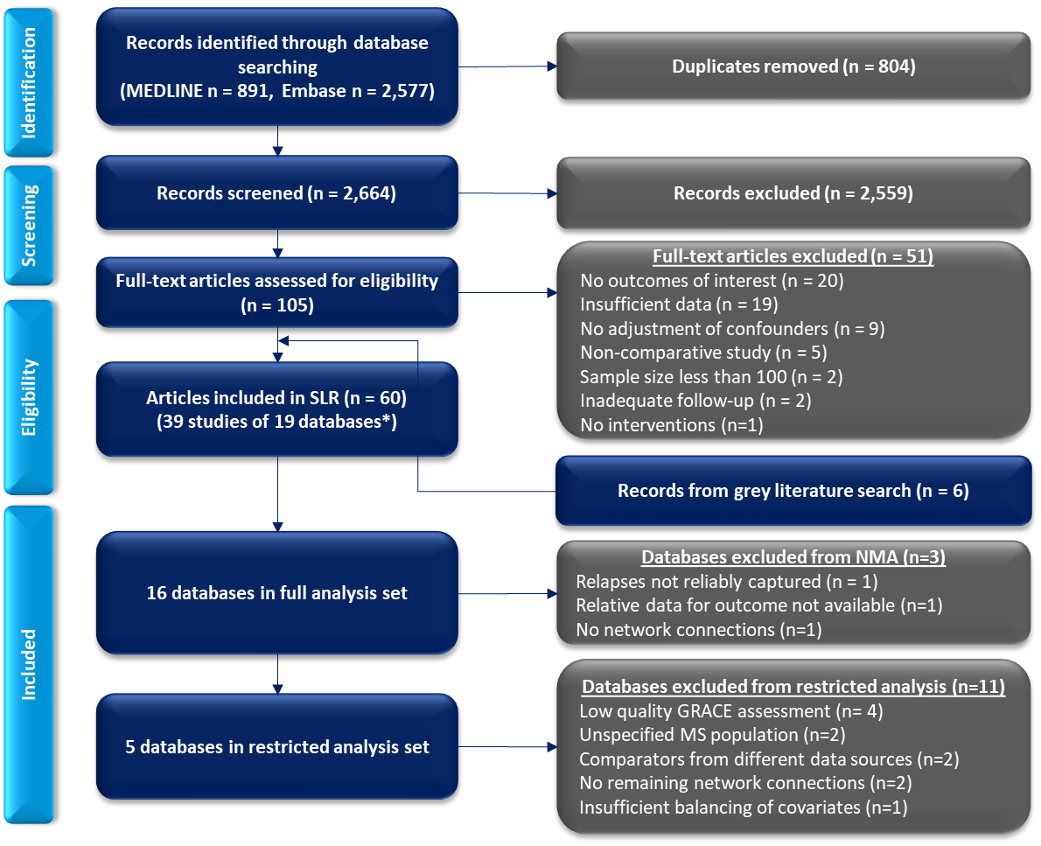
* For any given database (i.e., claims, registry, or cohort), there may be multiple studies/analyses conducted by different groups of authors and/or using varying analytical approaches. Even within individual studies, there may be multiple related publications/citations reporting on the same analysis.
Abbreviations: GRACE = Good Research for Comparative Effectiveness; MS = multiple sclerosis; NMA = network meta-analysis; SLR = systematic literature review

Three-level Meta-analysis Using Hypothetical Data from Related Study Publications of Real-world Evidence Databases

Exemplar Scenarios
- For the sake of simplicity, we assume meta-analysis of a simple continuous effect (which could be interpreted as a contrast between two treatments) that was not related to the actual systematic literature review (SLR)/network meta-analysis (NMA) data and was solely based on hypothetical data.
- The four scenarios described in Supplementary Table 4 were considered. Scenarios 1 and 3 consider meta-analyses of 10 observations from 10 independent data sources with no related publications, while Scenarios 2 and 4 consider meta-analyses of 30 observations across those same 10 independent data sources. These scenarios represent the situation in which there is strong sampling dependency across publications within database.
- Scenarios 1 and 2 consider homogeneous between-database results, while Scenarios 3 and 4 consider strongly heterogeneous between-database results. The between-database homogeneity/heterogeneity is manipulated by simply changing the within-study precision. All scenarios use matching point estimates for each database, and Scenarios 2 and 4 use matching point estimates for each kin study.

Supplementary Table 4. Exemplar Scenarios with hypothetical data from 10 studies
 | Scenario 1 | Scenario 2 | Scenario 3 | Scenario 4
Data Summary | No kins Homogeneous between-database results | Highly correlated kins Homogeneous between-database results | No kins Heterogeneous between-database results | Highly correlated kins Heterogeneous between-database results
Total number of databases | 10 | 10 | 10 | 10
Number of databases with related publications | 0 | 5 | 0 | 5
Total number of publications available for meta-analysis | 10 | 30 | 10 | 30
Exemplar Outcome estimates (continuous measure)
D1 | -2 | -2 | -2 | -2
D2 | -1 | -1 | -1 | -1
D3 | 0 | 0 | 0 | 0
D4 | 1 | 1 | 1 | 1
D5 | 2 | 2 | 2 | 2
D6 | 0 | -0.4, -0.2, 0, 0.2, 0.4 (mean* 0) | 0 | -0.4, -0.2, 0, 0.2, 0.4 (mean 0)
D7 | 1 | 0.6, 0.8, 1, 1.2, 1.4 (mean* 1) | 1 | 0.6, 0.8, 1, 1.2, 1.4 (mean 1)
D8 | 2 | 1.6, 1.8, 2, 2.2, 2.4 (mean* 2) | 2 | 1.6, 1.8, 2, 2.2, 2.4 (mean 2)
D9 | 3 | 2.6, 2.8, 3, 3.2, 3.4 (mean* 3) | 3 | 2.6, 2.8, 3, 3.2, 3.4 (mean 3)
D10 | 4 | 3.6, 3.8, 4, 4.2, 4.4 (mean* 4) | 4 | 3.6, 3.8, 4, 4.2, 4.4 (mean 4)
SE² of each estimate | 5 | 5 | 1 | 1
Three-level meta-analysis results
Mean (SE) | 1 (0.71) | 1.46 (0.59) | 1 (0.58) | 1.12 (0.58)
* Meta-analyzed mean
Abbreviation: SE = standard error

Data Analysis
- Scenario 1: A simple random effects (RE) meta-analysis found a mean effect of 1.0 with no heterogeneity (I² = 0, τ=0, p=0.74 for the Q-test of homogeneity).
- Scenario 2: A three-level meta-analysis was conducted using the rma.mv function of the metafor package (similar results were obtained using the meta3 function of the metaSEM package) [57], in which related publications were nested within database. The three-level meta-analysis found a mean effect of 1.46; this was the same result obtained in a follow-up analysis in which we conducted five fixed-effects (FE) meta-analyses within each set of the five related publications originating from the same database, and then meta-analyzed the results at the database level. The three-level meta-analysis model treated the five related studies within each database as completely independent: the precision of each of the databases with multiple related publications (D6 to D10) was improperly estimated as roughly five-fold higher than it “should” be, assuming that the results across each set of five related publications were highly dependent on one another.
- Scenario 3: A simple RE meta-analysis found a mean effect of 1.0 with significant heterogeneity (I² = 70%, τ=1.53, p=0.0004 for the Q-test of homogeneity).
- Scenario 4: A three-level meta-analysis using rma.mv found a mean effect of 1.12. Again, this was exactly the result obtained in a follow-up analysis in which we conducted five FE meta-analyses within each set of the five related publications originating from the same database, and then meta-analyzed the results at the database level. While the precision of each of the databases with multiple related publications (D6 to D10) was still improperly estimated as roughly five-fold higher than it “should” be, the nature of RE meta-analysis when I² is high is that studies are weighted more similarly. Thus, overly precise estimates of study effect give only slightly more weight to databases D6 through D10, and the resulting final estimate is less biased than in Scenario 2.
- The failure of the three-level model stems from its assumption of kin independence conditional on the random-effect of its specific database. This can be explicitly avoided in the multivariate approach, in which high within-database correlations can properly modify the estimate of the precision at the database level, but robust estimates of such correlations are difficult to generate. All conclusions here regarding the multilevel meta-analysis estimates of precision would apply to NMAs as well.

